

***Learners Today, Leaders Tomorrow!***

**Algebra 1 E Course Syllabus**

**Instructor: Mrs. Annmarie Maher, Room 315 North**

**E-Mail:** [**Annmarie.maher@slps.org**](mailto:Annmarie.maher@slps.org)

**COURSE FRAMEWORK:**

Algebra 150E is a course to help develop a student’s reasoning and critical thinking skills through mathematical application. This course helps students develop effective communication and deliver efficient responses to solve complex problems. For students looking to be a part of a STEM career, there is nothing more essential to their career than mathematical thinking.

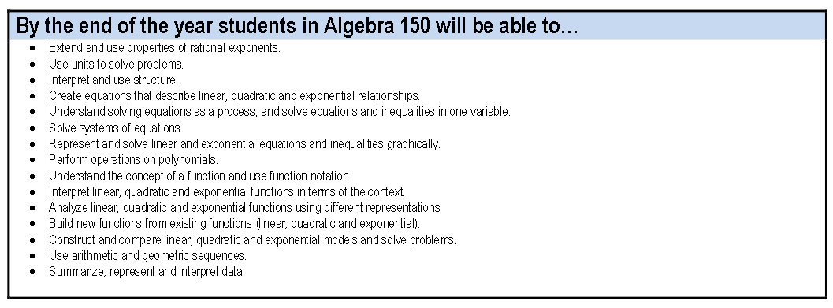

**UNITS AT A GLANCE**

1. **DATA AND STATISTICS**
2. **EQUATIONS AND INEQUALITIES**
3. **LINEAR EQUATIONS**
4. **FUNCTION BASICS**
5. **EXPONENT LAWS**
6. **EXPONENTIAL FUNCTIONS**
7. **QUADRATIC FUNCTIONS**

**LEARNING is a PROCESS**

Each unit will have multiple mastery checks that you will take at key points throughout the unit and one final test for that unit. You may be working at a faster or slower pace than those around you, but you will be expected to keep on pace to finish the unit by a certain date. If you finish material, extension material will be given to push you further! If you fail on a test or quiz, you will be able to retake the test to achieve mastery! You must complete the required extension work before you can retake the quiz or test.

Mastery Check and Unit Tests are available at a Mild 🌶️(80), Medium 🌶️🌶️(90), and Spicy 🌶️🌶️🌶️(100) level. You may self-select your level.

**GRADING POLICY/SCALE:**

**Assignments Descriptions Value**

Formative Practice Work, Homework = 36%

Summative Mastery Checks, Unit Tests, Projects = 54%

Final Exam S1 Exam and S2 Exam = 10%

**TOTAL = 100%**

**Semester Grade Policy:**

**Grade** **Grading Scale**

A 100 – 90

B 89 – 80

C 79 – 70

D 69 – 60

F 59 and below

**ACADEMIC INTEGRITY/ PLAGIARISM**

Students at Gateway STEM High School are expected to complete their own work, just as they would have to in the post-secondary and professional environment. Plagiarism/Copying of work will result in a zero on the assignment, parent contact and a referral.

**LATE WORK/MAKE-UP WORK/RETAKES**

If you miss a class, you can find the assignment for that day on TEAMS. All work will be due at the end of the instructional unit.

Mastery checks will be given weekly to help assess student learning of unit concepts, and the grades will be visible on Teams and in Focus. Students will have a bi-weekly check-in meeting with me. We will discuss work that needs to be resubmitted. Quizzes and tests may be retaken, but ALL retakes must be taken on your own time.

**REQUIRED MATERIALS**

You will have a class binder for keeping your work organized that is not completed online. It should remain in the classroom unless you need it for homework.

Your laptop will be used daily. You must bring it to class. You will be assigned and have access to a calculator in class.

Cell phones/earbuds should always be kept in your backpack. You will be given a verbal warning. Second reminder will result in placing the phone in the telephone booth. After three warnings, contact home will be made, a referral will be made, and a meeting will take place.