

Teacher:

Grade:

Student:

**Microsoft Teams Username: Microsoft Teams Password:**

**2020 - 2021**

**Hickey Elementary**

**School**

***Home of the***

***Mighty Hornets***



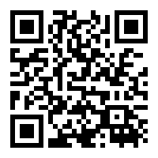

**Envision**

<https://savvasrealize.com/#/>

Username: __________________

Password: ___________________

**Guided Readers**

<https://my.guidedreaders.com/students/login>

Username: __________________

Password: ___________________

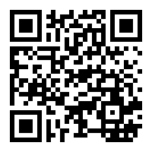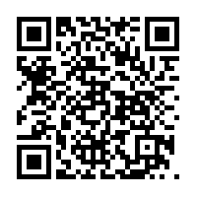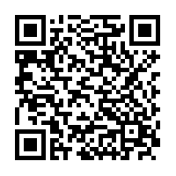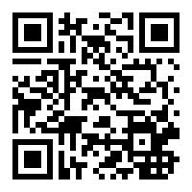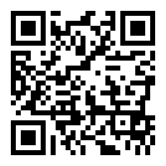

**Scantron Performance**

<http://www.performanceseries.com/>

Username: __________________

Password: ___________________

**MyOn**

<https://www.myon.com/school/SLPS-Hickey>

Username: __________________

Password: ___________________

**Class Dojo**

<https://www.classdojo.com/>

Username: __________________

Password: ___________________

**Khan Academy**

<https://www.khanacademy.org>

Username: __________________

Password: ___________________

**STAR**

<https://globalzone50.renaissance-go.com/welcomeportal/189390>

Username: __________________

Password: ___________________

**Scantron Achievement**

<http://www.achievementseries.com/>

Username: __________________

Password: ___________________

**National Geographic**

<https://www.myngconnect.com/login/student/textLogin/login.spr>

Username: __________________

Password: ___________________





**IXL**

<https://my.guidedreaders.com/students/login>

Username: __________________

Password: ___________________