**Directions for Signing in Microsoft Teams on a Computer, iPad, or Cell Phone Through the Internet. (NOTE: District iPads will already have a Microsoft Teams app icon.)**

1. Go to [Microsoft Teams](https://products.office.com/en-US/microsoft-teams/group-chat-software) <https://teams.microsoft.com/>
2. 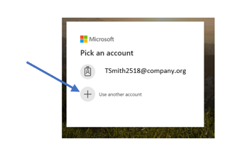If this screen pops up, select ***Use another account.***
3. Type in your student’s email address that the teacher provided. Make sure to type the entire email address. Ex: [tsmith2518@slps.org](mailto:tsmith2518@slps.org). If you are using your phone, it might prompt you to download the app at this time. Go ahead and click download the app.

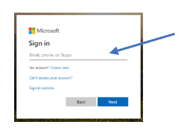

1. 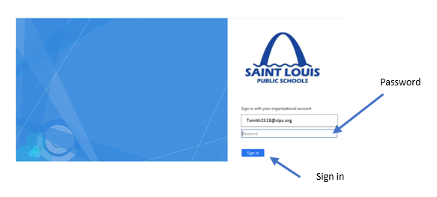Type in your student’s password. Then click Sign in.
2. You are ready to start. You can use Teams as a web-base or download the app on your computer or mobile phone. I have found it to work better as a app. To download the app, go to Step 6.

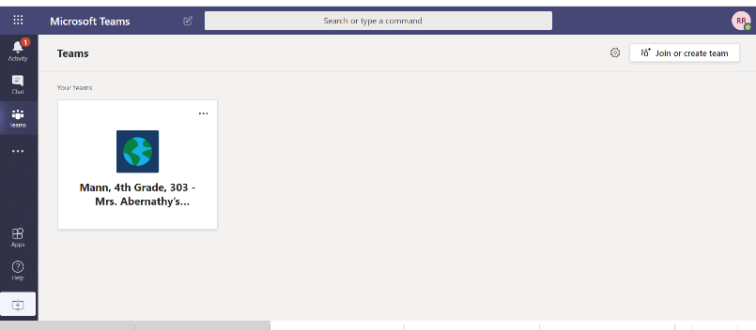

1. Click on the circle in the top right corner with your student’s initials. Then click on either ***Download the desktop app or Download the mobile app.***

