First Grade Supply List 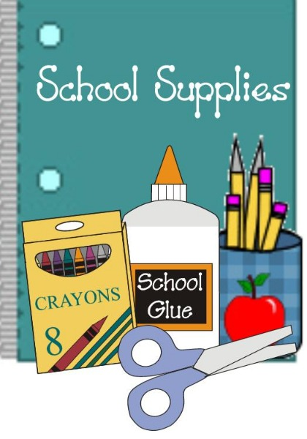

We share all of these supplies as a class!

**Please do not put your child’s name on items.**

**1 back pack with no wheels (labeled & full size, no rolling/mini backpacks)**

**1 1 inch binder (label your child’s name for portfolio)**

**2 24 box of Crayola crayons**

**1 pack of Crayola markers**

**1 pack No. 2 pencils, sharpened**

**1 pack of Expo Dry Erase Markers**

**2 pack of Elmer’s glue sticks**

# **1 Orange Five Star 2 Pocket Plastic Folder with Prongs**

# **1 BLUE Five Star 2 Pocket Plastic Folder with Prongs**

**2 boxes of tissues**

**3 containers Disinfectant Wipes (Clorox/ Lysol)**

**1 package of baby wipes**

**2 rolls of paper towels**

**4 containers of Play-Doh**

**1 Package Sandwich Ziploc Bags**

**1 Package of gallon Ziploc Bags**

**1 Package Band-Aids**