2020 - 2021 Reading List

# Imagine Your Story…

In St. Louis Public Schools, we provide all students access to high-quality literature that covers a wide range of topics. We use the “windows and mirrors” approach to literature exposure. This means that we want students to read books that reflect their own cultures, personalities, identities, etc. (mirrors) and we also want students to engage with titles that allow them a glimpse into the lives and experiences of others that may not reflect their own realities (windows). We strive to maintain a balance of “windows and mirrors” in our district ELA curriculum, but we also encourage students to engage in personal reading for pleasure that reflects this practice. **It is recommended that each student in grades 6-12 select a minimum of six titles from the lists provided for summer reading. Recommendations have been made by grade level based on the reading level and content of the text, but students may choose titles from any list if they desire.**

Young Adult literature often contains mature themes and topics that may not be suitable for every student. While we do not censor student reading selections in St. Louis Public Schools (as recommended by the National Council for Teachers of English and the International Literacy

Association), we do recommend consulting a source such as [Common Sense Media](https://www.commonsensemedia.org/) if you are concerned about the content presented in a

particular title. All of the titles contained in this Summer Reading List were recommended by SLPS

ELA/English teachers and have also been endorsed by a number of reputable literacy organizations around the world. Most of these titles are national award winners and are available in ebook, audio book, braille, and large print formats. All titles are available through the St. Louis Public Library.

If you have questions about any titles or would like support materials such as comprehension questions or discussion guides for a particular title, please contact Judine Keplar, ELA Curriculum Specialist by email (judine.keplar@slps.org).

## **St. Louis Public Library Resources**

**The St. Louis Public Library offers digital library cards. There is a quick form to fill out and a library card is generated for the patron. They have an amazing collection of e-books and audiobooks available without ever needing to leave the house. They also no longer issue fines for any late materials. Click** [**here**](https://slpl.bibliocommons.com/locations/?_ga=2.58828589.1849712780.1587943049-1731340543.1587943049) **for a list of St. Louis Public Library locations.**

E-Card: [https://www.slpl.org/ecard](https://www.slpl.org/ecard/)

All Downloadables:

https://www.slpl.org/resources-types/all-downloadables

Comics and Graphic Novels: [https://www.slpl.org/resources-types/comics-graphic-novels](https://www.slpl.org/resources-types/comics-graphic-novels/)

E-Audiobooks: [https://www.slpl.org/resources-types/audiobooks](https://www.slpl.org/resources-types/audiobooks/)

E-Books: <https://www.slpl.org/resources-types/ebooks>

Newspapers and Magazines:

[https://www.slpl.org/resources-types/newspapers-magazines](https://www.slpl.org/resources-types/newspapers-magazines/) [**American Street**](https://www.amazon.com/American-Street-Ibi-Zoboi/dp/0062473050/ref=sr_1_1?dchild=1&keywords=american+street&qid=1587565962&sr=8-1)

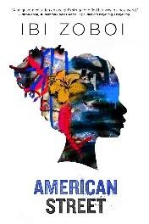

### Ibi Zoboi Lexile HL690

On the corner of American Street and Joy Road, Fabiola Toussaint thought she would finally find a good life. But after they leave Port-au-Prince, Haiti, Fabiola’s mother is detained by U.S. immigration, leaving

Fabiola to navigate her loud American cousins, Chantal, Donna, and Princess; the grittiness of Detroit’s west side; a new school; and a surprising romance, all on her own. Just as she finds her footing in this strange new world, a dangerous proposition presents itself, and Fabiola soon realizes that freedom comes at a cost. Trapped at the crossroads of an impossible choice, will she pay the price for the American dream?

[**Ghost Boys**](https://www.amazon.com/Ghost-Boys-Jewell-Parker-Rhodes/dp/0316262269/ref=sr_1_1?dchild=1&keywords=ghost+boys&qid=1587566323&sr=8-1)

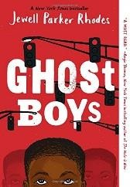

### Jewell Parker-Rhodes Lexile HL360, F&P Z

Twelve-year-old Jerome is shot by a police officer who mistakes his toy gun for a real threat. As a ghost, he observes the devastation that's been unleashed on his family and community in the wake of what they see as an unjust and brutal killing. Soon Jerome meets another ghost: Emmett Till, a boy from a very different time but similar circumstances. Emmett helps Jerome process what has happened, on a journey towards recognizing how historical racism may have led to the events that ended his life. Jerome also meets Sarah, the daughter of the police officer, who grapples with her father's actions. Once again Jewell Parker Rhodes deftly weaves historical and sociopolitical layers into a gripping and poignant story about how children and families face the complexities of today's world, and how one boy grows to understand American blackness in the aftermath of his own death.

[**If You Come Softly**](https://www.amazon.com/You-Come-Softly-Jacqueline-Woodson/dp/0142415227/ref=sr_1_1?crid=P0EYB2IW2411&dchild=1&keywords=if+you+come+softly&qid=1587592254&s=books&sprefix=if+you+come+%2Cstripbooks%2C165&sr=1-1)



### Jacqueline Woodson Lexile HL570, F&P Y

Jeremiah feels good inside his own skin. That is, when he's in his own Brooklyn neighborhood. But now he's going to be attending a fancy prep school in Manhattan, and black teenage boys don't exactly fit in there. So it's a surprise when he meets Ellie the first week of school. In one frozen moment their eyes lock, and after that they know they fit together--even though she's Jewish and he's black. Their worlds are so different, but to them that's not what matters. Too bad the rest of the world has to get in their way

[**The Mighty Miss Malone**](https://www.amazon.com/Mighty-Miss-Malone-Christopher-Curtis/dp/0440422140/ref=sr_1_1?crid=2L68S1T9F0DRG&dchild=1&keywords=mighty+miss+malone+book&qid=1587575763&s=books&sprefix=mighty+miss%2Cstripbooks%2C190&sr=1-1)

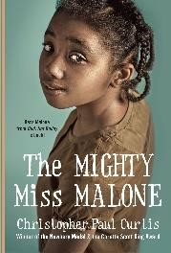

### Christopher Paul Curtis Lexile 750L, F&P U

Deza is the smartest girl in her class in Gary, Indiana, singled out by teachers for a special path in life. But it's 1936 and the Great Depression has hit Gary hard, and there are no jobs for black men. When her beloved father leaves to find work, Deza, Mother, and her older brother, Jimmie, go in search of him, and end up in a Hooverville outside Flint, Michigan. Jimmie leaves the camp to be a performer, while Deza and Mother find a new home, hoping to find Father. The twists and turns of their story reveal the devastation of the Depression.

[**One Crazy Summer**](https://www.amazon.com/One-Crazy-Summer-Rita-Williams-Garcia/dp/0060760907/ref=tmm_pap_swatch_0?_encoding=UTF8&qid=1587479520&sr=1-1)

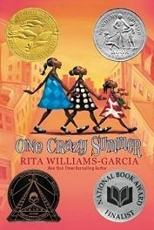

### Rita Williams-Garcia Lexile 750, F&P W

Three sisters travel to Oakland, California, in 1968 to spend a month with the mother they barely know, eleven-year-old Delphine and her two younger sisters arrive to a cold welcome as they discover that their mother

is resentful of the intrusion of their visit and wants them to attend a nearby Black Panther summer camp.

[**The Stars Beneath Our Feet**](https://www.amazon.com/Stars-Beneath-Our-Feet/dp/1524701270/ref=sr_1_1?crid=2QM9OYFGANPMS&dchild=1&keywords=the+stars+beneath+our+feet&qid=1587478916&s=books&sprefix=the+stars%2Cstripbooks%2C170&sr=1-1)

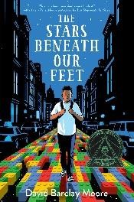

### David Barclay Moore Lexile 650L, F&P Z+

It’s Christmas Eve in Harlem, but twelveyear-old Lolly Rachpaul and his mom aren’t celebrating. They’re still reeling from his older brother’s death in a gang-related shooting. Then Lolly receives a gift that will change everything: two enormous bags filled with Legos. Faced with a pile of Legos and no instructions, Lolly must find his own way forward. His path isn’t clear-and the pressure to join a “crew,” as his brother did, is always there. When Lolly and his friend are beaten up and robbed, joining a crew almost seems like the safe choice. But building a Lego city at the community center provides Lolly with an escape and a bridge back to the world.

[**Tight**](https://www.amazon.com/Tight-Torrey-Maldonado/dp/1524740578/ref=tmm_pap_swatch_0?_encoding=UTF8&qid=1587478880&sr=1-1)

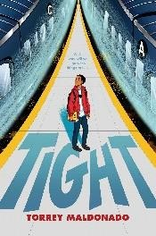

### Torrey Maldonado Lexile 600L, F&P Y

Bryan's mom has always encouraged his quiet, thoughtful nature, but his dad is different. He thinks it's time for the 6th grader to toughen up. With a quick temper and recently out of jail on probation, he tells Bryan it's better for a man to be feared than to be liked. Bryan's not really sure about this, and it doesn't seem to even matter when he befriends new kid Mike. Things get uncomfortable when it turns out Mike has some risky ideas about how to have fun. Bryan starts cutting school, jumping subway turnstiles and going train surfing, with Mike in the lead. But when Mike takes things a step too far and shows his true colors, Bryan has a difficult decision to make.

[**As Brave As You**](https://www.amazon.com/As-Brave-You-Jason-Reynolds/dp/1481415913/ref=tmm_pap_swatch_0?_encoding=UTF8&qid=1587479608&sr=1-1)

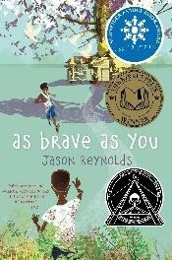

### Jason Reynolds Lexile 750

Genie's summer is full of surprises. He and his big brother, Ernie, are leaving Brooklyn for the very first time to spend the summer with their grandparents all the way in Virginia - in the COUNTRY! The second surprise comes when Genie figures out that their grandfather is blind. Genie thinks Grandpop must be the bravest guy he's ever known, but he starts to notice that his grandfather never leaves the house. When he finds the secret room that Grandpop is always disappearing into, he begins to wonder if his grandfather is really so brave after all. Then Ernie lets him down in the bravery department. It's his birthday, and Grandpop says to become a man you have to learn how to shoot a gun. Dumbfounded by Ernie's reluctance, Genie is left to wonder, are bravery and becoming a man only about proving something, or is it just as important to own up to what you won't do?

[**The Best At It**](https://www.amazon.com/Best-at-Maulik-Pancholy/dp/0062866419/ref=tmm_hrd_swatch_0?_encoding=UTF8&qid=1588175899&sr=1-1)

### Maulik Pancholy Lexile HL700

Rahul Kapoor is heading into seventh grade in a small town in Indiana. The start of middle school is making him feel increasingly anxious, so his favorite person

in the whole world, his grandfather, Bhai, gives him some well-meaning advice: Find one thing you're really good at and become the BEST at it.

[**The Boy in the Black Suit**](https://www.amazon.com/Boy-Black-Suit-Jason-Reynolds/dp/1442459514/ref=tmm_pap_swatch_0?_encoding=UTF8&qid=1587479189&sr=1-1)

### Jason Reynolds

Lexile HL760

Just when Matt thinks he can't handle one more piece of terrible news, he meets a girl who's dealt with a lot more--and who just might be able to clue him in on how to rise up when life keeps knocking him down. Matt wears a black suit every day. He wears the suit for his gig at the local funeral home, which pays way better than the Cluck Bucket, and he needs the income since his dad can't handle the bills his own. Then Matt meets Lovey. Crazy name, and she's been through more crazy stuff than he can imagine. Yet Lovey never cries. She's tough. Tough in the way Matt wishes he could be. There is nothing more hopeful than finding a person who gets your loneliness and who can help take it away.

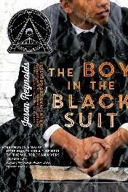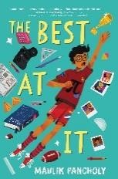

[**Challenger Deep**](https://www.amazon.com/Challenger-Deep-Neal-Shusterman/dp/0061134147/ref=tmm_pap_swatch_0?_encoding=UTF8&qid=1587479032&sr=1-1)

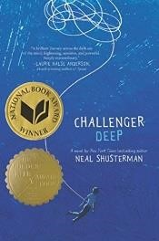

### Neal Schusterman Lexile HL800

A captivating novel about a teenage boy who struggles with schizophrenia that lingers long beyond the last page. Caden Bosch is on a ship that's headed for the deepest point on Earth: Challenger Deep,

the southern part of the Marianas Trench. Caden Bosch is a brilliant high school student whose friends are starting to notice his odd behavior. Caden Bosch is designated the ship's artist in residence to document the journey with images. Caden Bosch pretends to join the school track team but spends his days walking for miles, absorbed by the thoughts in his head.

[**Illegal**](https://www.amazon.com/Illegal-Eoin-Colfer/dp/1492665827/ref=sr_1_1?crid=B4BC2XZGJ1FN&dchild=1&keywords=illegal+eoin+colfer&qid=1587577776&s=books&sprefix=illegal%2Cstripbooks%2C186&sr=1-1)



### Eoin Colfer and Andrew Donkin Lexile GN490

A moving graphic novel that explores the current plight of undocumented immigrants. Ebo is alone. His brother,

Kwame, has disappeared, and Ebo knows it can only be to attempt the journey to Europe, and a better life Ebo refuses to be left behind in Ghana. He sets out after Kwame and joins him on the quest to reach Europe. But with every step he holds on to his hope for a new life, and a reunion with his family.

[**The Girl Who Drank the Moon**](https://www.amazon.com/Girl-Drank-Winner-Newbery-Medal/dp/1616207469/ref=sr_1_1?crid=3H5ZJO1XQ12CK&dchild=1&keywords=girl+who+drank+the+moon+book&qid=1587479648&s=books&sprefix=girl+who+%2Cstripbooks%2C175&sr=1-1)

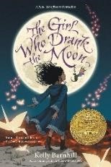

### Kelly Barnhill Lexile 640, F&P X

Each year, the people of the Protectorate leave a baby as an offering to the witch who lives in the forest. They hope this sacrifice will keep her from ruining their

town. But the witch in the Forest, Xan, is kind. Xan rescues the children and delivers them to families on the other side of the forest, feeding the babies starlight on the journey. One year, Xan feeds a baby moonlight instead of starlight, filling the ordinary child with extraordinary magic. Xan decides she must raise this girl, whom she calls Luna, as her own. As Luna's 13th birthday approaches, her magic begins to emerge with dangerous consequences.

[**The Promise of Change**](https://www.amazon.com/This-Promise-Change-School-Equality/dp/1681198525/ref=sr_1_1?dchild=1&keywords=the+promise+of+change&qid=1588172380&s=books&sr=1-1)

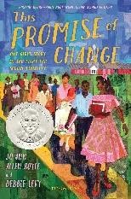

### Jo Ann Allen Boyce Lexile 1000L

In 1956, one year before federal troops escorted the Little Rock 9 into Central High School, fourteen-year-old Jo Ann Allen was one of twelve African-American students

who broke the color barrier and integrated Clinton High School in Tennessee. At first things went smoothly, but then outside agitators interfered, pitting the townspeople against one another. Jo Ann - popular among both black and white students, found herself called on as the spokesperson of the group. This is the story of her four months thrust into the national spotlight and as a trailblazer in history.

[**All American Boys**](https://www.amazon.com/All-American-Boys-Jason-Reynolds/dp/1481463349/ref=tmm_pap_swatch_0?_encoding=UTF8&qid=1587479559&sr=1-2)

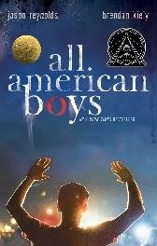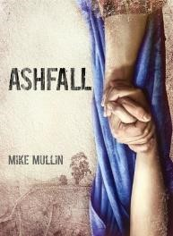

### Jason Reynolds, Brendan Kiely Lexile HL770, F&P Z+

Two teens-one black, one white-grapple with the repercussions of a single violent act that leaves their school, their community, and, ultimately, the country bitterly divided by racial tension.

[**Ashfall**](https://www.amazon.com/Ashfall-Trilogy-Mike-Mullin/dp/1933718749/ref=tmm_pap_swatch_0?_encoding=UTF8&qid=1587944134&sr=1-1)

### Mike Mullen Lexile 570L

Under Yellowstone National Park is a super volcano. Most people don't know it's there. It just could be overdue for an eruption, which would change the landscape and climate of our planet. For Alex, being left alone for the weekend means having the freedom to play computer games and hang out with his friends without hassle from his mother. Then the volcano erupts, plunging his hometown into a nightmare of darkness, ash, and violence. Alex begins a harrowing trek to search for his family and finds help in Darla, a travel partner he meets along the way. Together they must find the strength and skills to survive and outlast an epic disaster.

[**Clean Getaway**](https://www.amazon.com/Clean-Getaway-Nic-Stone/dp/1984892975/ref=tmm_hrd_swatch_0?_encoding=UTF8&qid=1587478936&sr=1-1)

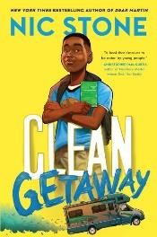

### Nic Stone Lexile 780, F&P W

For the life of him, 'Scoob' Lamar can't seem to stay out of trouble-and now the run-ins at school have led to lockdown at home. So when Grandma, Scoob's favorite person on Earth, asks him to go on an impromptu road trip, he's in the RV faster than he can say freedom. With Grandma's old maps at their side, the pair set off on a journey down Grandma's memory lane. But adventure quickly turns to uncertainty: Grandma keeps changing the license plate, dodging Scoob's questions, and refusing to check Dad's voice mails. The farther they go, the more Scoob realizes that things aren't always what they seem-Grandma included. [**I Can Make This Promise**](https://www.amazon.com/I-Can-Make-This-Promise/dp/0062871994/ref=tmm_hrd_swatch_0?_encoding=UTF8&qid=1588178595&sr=1-1)

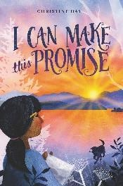

### Christine Day Lexile 780, F&P W

All her life, Edie has known that her mom was adopted by a white couple. So, no matter how curious she might be about her Native American heritage, Edie is sure her family doesn’t have any answers. When twelve-year-old Edie finds letters and photographs in her attic that change everything she thought she knew about her Native American mother's adoption, she realizes she has a lot to learn about her family's history and her own identity.

[**The Other Wes Moore**](https://www.amazon.com/Other-Wes-Moore-Name-Fates/dp/0385528205/ref=sr_1_1?dchild=1&keywords=the+other+wes+moore&qid=1587571402&s=books&sr=1-1)

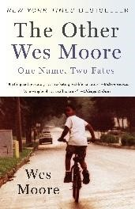

### Wes Moore Lexile 990L

Two kids with the same name lived in the same decaying city. One went on to be a Rhodes Scholar, decorated combat veteran, White House Fellow, and business leader. The other is serving a life sentence in prison. Here is the story of two boys and their journey. Told in alternating dramatic narratives that take readers from heart-wrenching losses to moments of surprising redemption, The Other Wes Moore tells the story of a generation of boys trying to find their way in a hostile world.

[**Piecing Me Together**](https://www.amazon.com/Piecing-Me-Together-Ren%C3%A9e-Watson/dp/1681191075/ref=sr_1_1?crid=1FZMZYYCPDVFY&dchild=1&keywords=piecing+me+together&qid=1588168090&s=books&sprefix=piecing+me+%2Caps%2C197&sr=1-1)

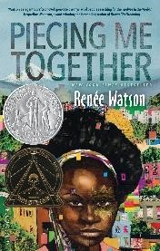

### Renee Watson Lexile 680L

Jade believes she must get out of her poor neighborhood if she's going to succeed. Her mother tells her to take advantage of every opportunity that comes her way.

And Jade has: every day she rides the bus away from her friends and to the private school where she feels like an outsider, but where she has plenty of opportunities. But some opportunities she doesn't really welcome, like an invitation to join Women to Women, a mentorship program for "at-risk" girls. She's tired of being singled out. She wants to speak, to create, to express her joys and sorrows, her pain and her hope. Maybe there are some things she could show other women about understanding the world and finding ways to be real.

[**Rebound**](https://www.amazon.com/Rebound-Dawud-Anyabwile-illustrator-Alexander/dp/1783447206/ref=tmm_pap_swatch_0?_encoding=UTF8&qid=1588177594&sr=1-1)

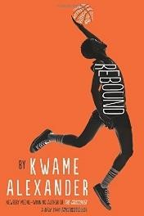

### Kwame Alexander Lexile 780L, F&P Y

Grieving the loss of his father, all Chuck wants to do is escape into his comics but, instead, his mother sends him to his grandparents’ home for the summer. With the help of his stern grandfather and his basketball-loving cousin, he learns about his past and how to face the future.

[**Sal and Gabi Break the Universe**](https://www.amazon.com/Gabi-Break-Universe-Novel-Book/dp/1368023622/ref=tmm_pap_swatch_0?_encoding=UTF8&qid=1588178328&sr=1-1)

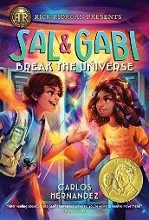

### Carlos Hernandez Lexile 700L

When Sal Vidon meets Gabi Real for the first time, it isn't under the best of circumstances. Sal is in the principal's office for the third time in three days, and it's still the first week of school. Gabi, student council president and editor of the school paper, is there to support her friend Yasmany, who just picked a fight with Sal. When Gabi learns that he's capable of conjuring things much bigger than a chicken--including his dead mother--and she takes it all in stride, Sal knows that she is someone he can work with. There's only one slight problem: their manipulation of time and space could put the entire universe at risk.

## -10

[**Children of Blood and Bone**](https://www.amazon.com/Children-Blood-Bone-Legacy-Orisha/dp/1250294622/ref=tmm_pap_swatch_0?_encoding=UTF8&qid=1587479149&sr=1-1)

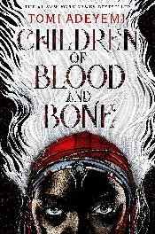

### Tomi Adeyemi Lexile HL670

Seventeen-year-old Zelie, her brother Tzain, and Princess Amari fight to restore magic to the land and activate a new generation of magi, but they are ruthlessly pursued by Prince Inan, who believes the return of magic will mean the end of the monarchy.

[**Dear Martin**](https://www.amazon.com/Dear-Martin-Nic-Stone/dp/1101939524/ref=sr_1_1?dchild=1&keywords=dear+martin&qid=1587592119&s=books&sr=1-1)

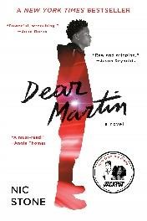

### Nic Stone Lexile HL720

Justyce McAllister is a good kid, an honor student, and always there to help a friend—but none of that matters to the police officer who just put him in handcuffs. Despite leaving his rough neighborhood behind, he can't escape. Justyce looks to the teachings of Dr. Martin Luther King Jr. for answers. But do they hold up anymore? He starts a journal to Dr. King to find out. Then comes the day Justyce goes driving with his best friend, Manny, windows rolled down, music turned up—way up, sparking the fury of a white off-duty cop beside them. Words fly. Shots are fired. Justyce and Manny are caught in the crosshairs. In the media fallout, it's Justyce who is under attack.

[**Hidden Figures: Young**](https://www.amazon.com/Hidden-Figures-Readers-Margot-Shetterly/dp/0062662376/ref=sr_1_2?crid=8GU3XB8NTN5&dchild=1&keywords=hidden+figures+young+readers%27+edition&qid=1587575838&s=books&sprefix=hidden+%2Cstripbooks%2C249&sr=1-2)

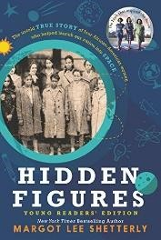

[**Readers’ Edition**](https://www.amazon.com/Hidden-Figures-Readers-Margot-Shetterly/dp/0062662376/ref=sr_1_2?crid=8GU3XB8NTN5&dchild=1&keywords=hidden+figures+young+readers%27+edition&qid=1587575838&s=books&sprefix=hidden+%2Cstripbooks%2C249&sr=1-2)

### Margot Lee Shetterly Lexile 1120L, F&P Y

Before John Glenn orbited the earth, or Neil Armstrong walked on the moon, a group of female mathematicians known as “human computers” used pencils, slide rules, and adding machines to calculate the numbers that would launch rockets and astronauts, into space. This book brings to life the stories of four women who lived through the Civil Rights era, the Space Race, the Cold War, and the movement for gender equality, and whose work forever changed the face of NASA and the country.

[**Long Way Down**](https://www.amazon.com/Long-Way-Down-Jason-Reynolds/dp/1481438263/ref=tmm_pap_swatch_0?_encoding=UTF8&qid=1587944963&sr=1-1)

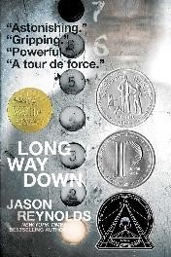

### Jason Reynolds Lexile HL720, Lexile Z_

As Will, fifteen, sets out to avenge his brother Shawn's fatal shooting, seven ghosts who knew Shawn board the elevator and reveal truths Will needs to know. Told in short, fierce staccato narrative verse, Long Way Down is a fast and furious, dazzlingly brilliant look at teenage gun violence, as could only be told by Jason Reynolds.

[**Pride**](https://www.amazon.com/Pride-Ibi-Zoboi/dp/0062564056/ref=tmm_pap_swatch_0?_encoding=UTF8&qid=1587479763&sr=1-1)

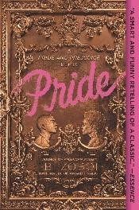

### Ibi Zoboi Lexile HL760

Pride and Prejudice gets remixed in this smart, funny, gorgeous retelling of the classic, starring all characters of color. Zuri Benitez has pride. Brooklyn pride, family pride, and pride in her Afro-Latino roots. But pride might not be enough to save her rapidly gentrifying neighborhood from becoming unrecognizable. When the wealthy Darcy family moves in across the street, Zuri wants nothing to do with their two teenage sons, even as her older sister, Janae, starts to fall for the charming Ainsley. She especially can't stand the judgmental and arrogant Darius. Yet as Zuri and Darius are forced to find common ground, their initial dislike shifts into an unexpected understanding. But with four wild sisters pulling her in different directions, cute boy Warren vying for her attention, and college applications hovering on the horizon, Zuri fights to find her place in Bushwick's changing landscape or lose it all.

[**Red Queen**](https://www.amazon.com/Red-Queen-Victoria-Aveyard/dp/0062310631/ref=tmm_hrd_swatch_0?_encoding=UTF8&qid=1587479794&sr=1-1) **(series)**

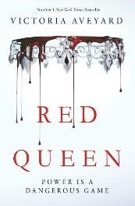

### Victoria Aveyard Lexile HL740

In a world divided by blood-those with common, Red blood serve the Silverblooded elite, who are gifted with superhuman abilities-seventeen-year-old

Mare, a Red, discovers she has an ability of her own. To cover up this impossibility, the king forces her to play the role of a lost Silver princess and betroths her to one of his own sons. But Mare risks everything and uses her new position to help the Scarlet Guard--a growing Red rebellion--even as her heart tugs her in an impossible direction.

[**Speak**](https://www.amazon.com/Speak-Laurie-Halse-Anderson/dp/0312674392/ref=sr_1_1?dchild=1&keywords=speak&qid=1587571493&s=books&sr=1-1)



### Laurie Halse Anderson Lexile 690L, F&P Z

"Speak up for yourself--we want to know what you have to say." From the first moment of her freshman year, Melinda knows this is a big fat lie, part of the nonsense of high school. She is friendless,

outcast, because she busted an end-of-summer party by calling the cops, so now nobody will talk to her, let alone listen to her. As time passes, she becomes increasingly isolated and practically stops talking altogether. Only her art class offers any solace, and it is through her work on an art project that she is finally able to face what really happened at that terrible party: she was raped by an upperclassman, a guy who still attends her school and is still a threat to her. Her healing process has just begun when she has another violent encounter with him. But this time Melinda fights back, refuses to be silent, and thereby achieves a measure of vindication.

## Grade 11-12

[**The Absolutely True Diary of a**](https://www.amazon.com/Absolutely-True-Diary-Part-Time-Indian/dp/0316013692/ref=sr_1_1?crid=3TZ6SLGLX8D8S&dchild=1&keywords=absolutely+true+story+of+a+part+time+indian&qid=1587577240&s=books&sprefix=absolutely%2Cstripbooks%2C187&sr=1-1)

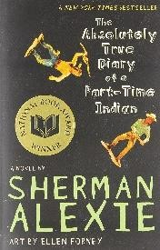

[**Part Time Indian**](https://www.amazon.com/Absolutely-True-Diary-Part-Time-Indian/dp/0316013692/ref=sr_1_1?crid=3TZ6SLGLX8D8S&dchild=1&keywords=absolutely+true+story+of+a+part+time+indian&qid=1587577240&s=books&sprefix=absolutely%2Cstripbooks%2C187&sr=1-1)

### Sherman Alexie Lexile 600L, F&P Z+

This hilarious novel tells the story of Junior, a budding cartoonist growing up on the Spokane Indian Reservation.

Determined to take his future into his own hands, Junior leaves his troubled school on the rez to attend an all-white farm town high school where the only other Indian is the school mascot.

[**Bronx Masquerade**](https://www.amazon.com/Bronx-Masquerade-Nikki-Grimes/dp/0425289761)



### Nikki Grimes Lexile 670L, F&P Z+

When Wesley Boone writes a poem for his high school English class, some of his classmates clamor to read their poems aloud too. Soon they're having weekly poetry sessions and, one by one, the eighteen students are opening up and taking on the risky challenge of self-revelation. Through the poetry they share and narratives in which they reveal their most intimate thoughts about themselves and one another, their words and lives show what lies beneath the skin, behind the eyes, beyond the masquerade.[**Children of Virtue and**](https://www.amazon.com/Children-Virtue-Vengeance-Legacy-Orisha/dp/1250170990/ref=tmm_hrd_swatch_0?_encoding=UTF8&qid=1587479231&sr=1-1)

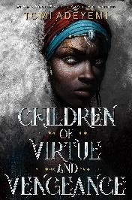

[**Vengeance**](https://www.amazon.com/Children-Virtue-Vengeance-Legacy-Orisha/dp/1250170990/ref=tmm_hrd_swatch_0?_encoding=UTF8&qid=1587479231&sr=1-1)

### Tomi Adeyemi Lexile HL680

After battling the impossible, Zélie and

Amari have finally succeeded in bringing magic back to the land of Orïsha. But the ritual was more powerful than they

could’ve imagined, reigniting the powers of not only the maji, but of nobles with magic ancestry, too. Now, Zélie struggles to unite the maji in an Orïsha where the enemy is just as powerful as they are. But when the monarchy and military unite to keep control of Orïsha, Zélie must fight to secure Amari's right to the throne and protect the new maji from the monarchy's wrath. With civil war looming on the horizon, Zélie finds herself at a breaking point.

[**Little Fires Everywhere**](https://www.amazon.com/Little-Fires-Everywhere-Movie-Tie/dp/014313566X/ref=tmm_pap_swatch_0?_encoding=UTF8&qid=1587479692&sr=1-1)



### Celeste NG Lexile 1000L

In Shaker Heights, everything is planned-from the layout of the roads, to the colors of the houses, to the lives its residents will go on to lead. And no one embodies this spirit more than Elena Richardson, whose guiding principle is playing by the rules.

Enter Mia Warren--an artist and single mother who arrives in this idyllic bubble with her teenaged daughter Pearl and rents a house from the Richardsons.

Soon Mia and Pearl become more than tenants. But Mia carries with her a mysterious past and a disregard for the status quo that threatens to upend this carefully ordered community. When old family friends of the Richardsons attempt to adopt a Chinese-American baby, a custody battle erupts that dramatically divides the town--and puts Mia and Elena on opposing sides. Suspicious of Mia and her motives, Elena is determined to uncover the secrets in Mia's past. But her obsession will come at unexpected and devastating cost.

[**Look Both Ways**](https://www.amazon.com/Look-Both-Ways-Tale-Blocks/dp/1481438298/ref=tmm_pap_swatch_0?_encoding=UTF8&qid=&sr=)

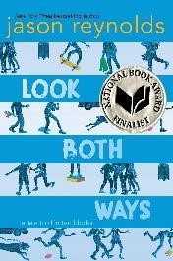

### Jason Reynolds Lexile 750L

This story was going to begin like all the best stories. With a school bus falling from the sky. But no one saw it happen. They were all too busy - Talking about boogers. Stealing pocket change. Skateboarding. Braving up. Executing complicated handshakes. Planning an escape. Making jokes. But mostly, too busy walking home. Jason Reynolds conjures ten tales about what happens after the dismissal bell rings, and brilliantly weaves them into one funny, poignant look at the detours we face on the walk home, and in life.

[**On the Come Up**](https://www.amazon.com/Come-Up-Angie-Thomas/dp/0062498568/ref=tmm_hrd_swatch_0?_encoding=UTF8&qid=1587479274&sr=1-1)

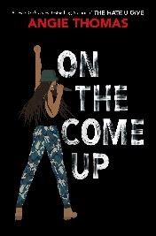

### Angie Thomas Lexile HL550

Sixteen-year-old Bri wants to be one of the greatest rappers of all time. Or at least win her first battle. As the daughter of a hip-hop legend who died right before he hit big, Bri’s got big shoes to fill. But it’s hard to get your come up when you’re labeled a hoodlum at school, and your fridge at home is empty after your mom loses her job. Bri pours her anger and into her first song, which goes viral for all the wrong reasons. Bri soon finds herself at the center of a media controversy. But with an eviction notice staring her family down, Bri doesn’t just want to make it—she has to. Even if it means becoming the very thing the public has made her out to be.

[**With the Fire on High**](https://www.amazon.com/Fire-High-Elizabeth-Acevedo-dp-006266283X/dp/006266283X/ref=mt_hardcover?_encoding=UTF8&me=&qid=1587479833)



### Elizabeth Acevedo Lexile 810L

Ever since she got pregnant freshman year, Emoni Santiago’s life has been about making the tough decisions—doing what has to be done for her daughter.

The one place she can let all that go is in the kitchen, where she adds a little something magical to everything she cooks, turning her food into straight-up goodness. Even though she dreams of working as a chef after she graduates, Emoni thinks that it’s not worth her time to pursue the impossible. But once Emoni starts cooking, her only choice is to let her talent break free.