
Cosmetology
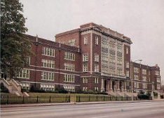

Welcome to the world of professional Cosmetology. Our Cosmetology program is a two-year program which begins junior year. It is mandatory for students to be in attendance to receive the required 1250 hours as stated in Missouri State Board Rules and Regulation.
Classes are set in a very fast paced environment with a steep learning curve. Success requires committed students willing to fully engage the classes as a profession. With the completion of a sequence of classes, you will have the skills necessary to obtain a Cosmetology License through Missouri State Board of Cosmetology and Barbering. We explore every facet of the fundamentals of Cosmetology, as well as learn the vital practice of Professional Ethics and Entrepreneurship. 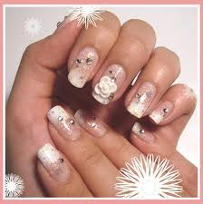



Beaumont
Blue Jackets!
Cosmetology Program
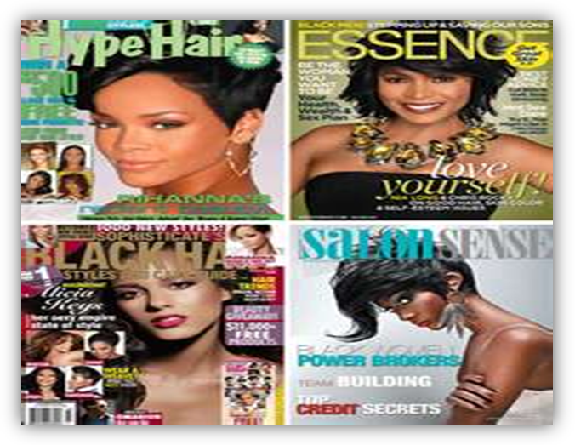
Beaumont Career and Technical High School
3836 Natural Bridge Avenue
St. Louis, MO 63107
314-533-2410

Michael Brown
Principal
Responsibility, Choices, Consequences
Teacher Ms.Sonya Sanders
B

.

Cosmetology
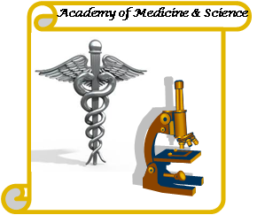Program of Study

Junior Year

• American Literature/Comp
• American History
• Algebra
• Biology
• ACT/SAT Prep
• Foreign Language
• Cosmetology Level 1
`

648 hours LEVEL I - First Year
Teaching the Basics
Introduction to Cosmetology and Beauty Culture Industry
Professional Image and Hygiene
Salon Safety and OSHA standards
Bacteriology, Sanitation and Sterilization, Electricity, Anatomy and Physiology
Preparation of a Client for various services, Shampooing the Hair
Hairstyling - Roller Setting, Pin Curls, Blow Dryer and Curling Iron Techniques, Braiding
Scalp Treatment, Facial, Arching Eyebrows, Applying Make-up
Basic Manicuring, Arm and Hand Massage
Permanent Waving
Hair-coloring using Rinses, Semi-permanent and Permanent Hair Color, Lightening Techniques
Basic Hair-cutting

648 hoursLevel II - Second Year
Review from First Year and More In-Depth Techniques
Advanced Hairstyling, Blow Drying, Roller Setting, Updos, French Twist,
Finger Wave, Specialty Scalp Treatments, Facials- Masks, Waxes
Manicuring, Gel nails, Nail tips, Nail repairs
Men’s manicure, Pedicures
Give a Special Permanent Wave Wrap, Soft Waves
Relaxers - Sodium Hydroxide and Thio Relaxer
Basic and Advanced Hair-cutting Techniques and Styles, Cutting Bangs, Angles
Clipper-Cutting, Men’s Hair-cutting
Advanced Lightening Techniques with Different Products
Review, Some New Items, Getting Ready for the State Board Exam
Mock Boards
Hairstyling - Styling a Wiglet, Extensions, Permanent Waving,
Hair Coloring, Back Massage
Salon Management
Total required hours 1,250

Beaumont High School’s Mission

Tomorrow and for generations to come depends on our youth success, we will work as a partner and mentor to help you succeed.

