Pathway Courses
- Introduction to Construction Trades
Certifications / Credentials
- OSHA 10/30 hr.
- CPR/First Aid

Post-Secondary Credit
- Dual enrollment
- Ranken Technical College

Employment Opportunities
- Journeymen
- Apprenticeship
- Laborer

Student Organization(s)

- SLATE

Off-Campus Programs
- Internships – Y
- Job Shadowing – Y

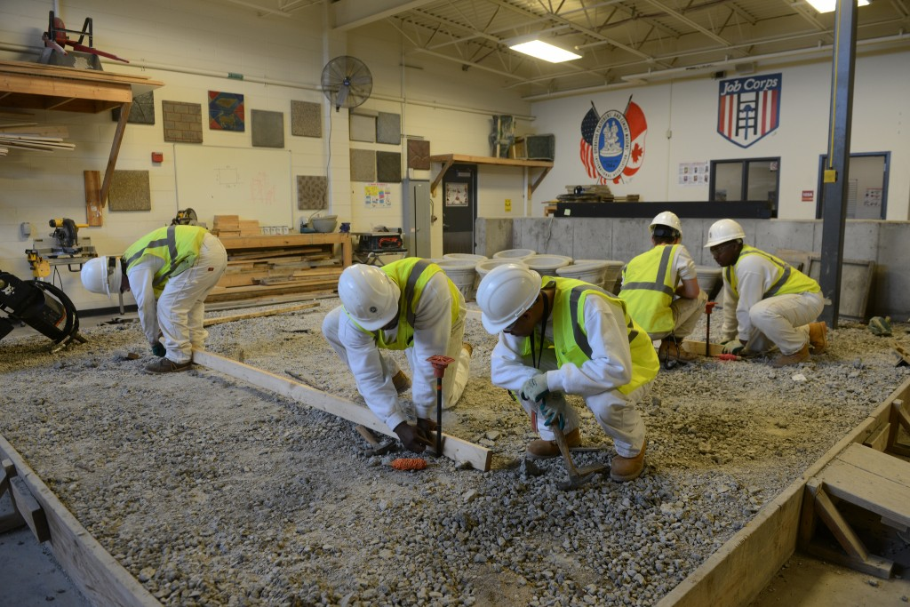
Introduction to Construction Trades/Practice & Skill Development
This course introduces students to core construction trade competencies for varying general labor/skill employment within the construction field. The course includes instruction in basic blueprint reading and application; communication and interpersonal skills; safety & OSHA requirements; computer technology and construction mathematic calculation.
Entrance Requirements
- GPA Recommendations: 2.0 or greater core subject area
- Completion of 2 pg. essay on: “Why Do You Want to Pursue a Career in the Construction field”?
Juniors
- Composition/Grammar/ American History
- Algebra
- ACT/SAT Prep
Seniors
- English /Government
- College Summit
- Geometry/College Algebra
Class requirements
Students can bring $50 to cover equipment/uniform requirements or provide the following on their own: steel toed safety work boots, carpenter’s pants (not cargo pants), long sleeved, collared, button up work shirt, & a hard hat.

Phone: 314-231-3720 | Fax: 314-345-4540

