WHAT DRIVES A REACTION TO BE SPONTANEOUS?

  - ENTHALPY (ΔH) – heat content (exothermic reactions are generally favored)
  - ENTROPY (ΔS) – disorder of a system (more disorder is favored) Nature tends toward
chaos! Think about your room at the end of the week! Your mom will love this law.
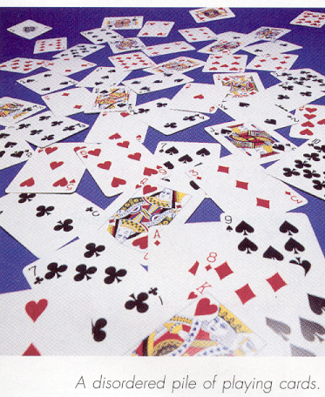
Spontaneous reactions are those that occur without outside intervention. They may occur fast OR slow (that is kinetics). Some reactions are very fast (like combustion of hydrogen) other reactions are very slow (like graphite turning to diamond)

ENTROPY:
The second law of thermodynamics: the universe is constantly increasing disorder. Rudolph Clausius (you=ll hear lots about him later when we study vapor pressures) Adiscovered@ it and gave it its symbol.)

The third law of thermodynamics: the entropy of a perfect crystal at 0K is zero.
[not a lot of perfect crystals out there so, entropy values are RARELY ever zero—even
elements]
So what? This means the absolute entropy of a substance can then be determined at any temp. higher than 0 K. (Handy to know if you ever need to defend why G & H for elements = 0. . . . BUT S does not!)

Predicting the entropy of a system based on physical evidence:
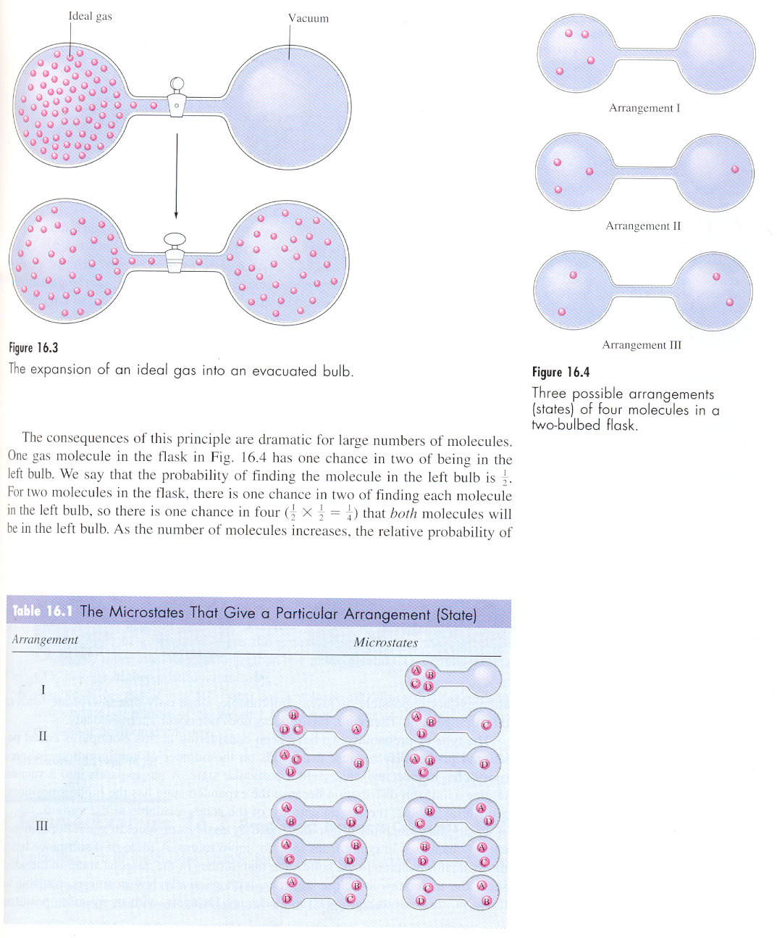
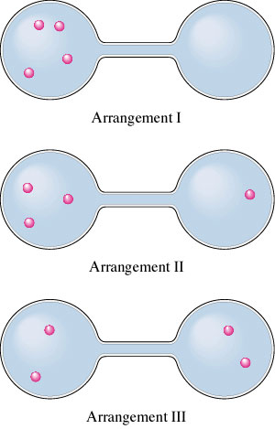
- The greater the disorder or randomness in a system, the larger the entropy.
- The entropy of a substance always increases as it changes from solid to liquid to gas.
- When a pure solid or liquid dissolves in a solvent, the entropy of the substance increases (carbonates are an exception!--they interact with water and actually bring MORE order to the system)
- When a gas molecule escapes from a solvent, the entropy increases
- Entropy generally increases with increasing molecular complexity (crystal structure: KCl vs CaCl₂) since there are more MOVING electrons!
- Reactions increasing the number of moles of particles often increase entropy.

- In general, the greater the number of arrangements, the higher the entropy of the system!

Exercise 2 Predicting Entropy Changes
Predict the sign of the entropy change for each of the following processes.

A: Solid sugar is added to water to form a solution.
B: Iodine vapor condenses on a cold surface to form crystals.

Calculating Entropy from tables of standard values: (Just the same as calculating the enthalpy earlier)
Sample Problem A:
Which of the following has the largest increase in entropy?
- CO_{2(s)} → CO_{2(g)}
- H_{2(g)} + Cl_{2(g)} → 2 HCl_{(g)}
- KNO_{3(s)} → KNO_{3(l)}
- C_{(diamond)} → C_{(graphite)}

S is + when disorder increases (favored)
BIG MAMMA, verse 2: ΔS_{rxn} = Σ ΔS _{(products)} - Σ ΔS _{(reactants)}
S is – when disorder decreases
Units are usually J/K mol (not kJ ---tricky!)

Sample Problem B:
Calculate the entropy change at 25°C, in J/K for:
2 SO_{2(g)} + O_{2(g)} → 2 SO_{3(g)}

Given the following data:
SO_{2(g)} 248.1 J/K mol
O_{2(g)} 205.3 J/Kmol
SO_{3(g)} 256.6 J/K mol

ENTROPY CHANGES FOR REVERSIBLE PHASE CHANGES ☹ that=s a phase change at constant temperature

- ΔS = heat transferred = q
temperature at which change occurs T

**where the heat supplied (endothermic) (q > 0) or evolved (exothermic) (q < 0) is divided by the temperature in Kelvins
** It is important here to note if the reaction is endothermic or exothermic. The actual significance of this is really dependent on the temperature at which the process occurs.
(i.e., If you gave a millionaire $100 it would not make much difference in his happiness; if you gave a poor college student $100 it would create a totally different expression of happiness!)

EX: water (l @ 100)  water (g @ 100)
the entropy will increase

- Taking favored conditions into consideration, the equation above rearranges into:
ΔS = - ΔH
T

- Give signs to ΔH following exo/endo guidelines! (If reaction is exo.; entropy of system increases—makes sense!)

Exercise 4 Determining ∆S_{surr}
In the metallurgy of antimony, the pure metal is recovered via different reactions, depending on the composition of the ore. For example, iron is used to reduce antimony in sulfide ores:
Sb₂S₃(s)+3Fe(s)→2Sb(s)+3FeS(s) ∆H = -125kJ
Carbon is used as the reducing agent for oxide ores:
Sb₄O₆(s)+6C(s)→4Sb(s)+6CO(g) ∆H = 778kJ
Calculate ∆S_{surr} for each of these reactions at 25°C and 1 atm.

SUMMARY ENTROPY:
ΔS = + MORE DISORDER (FAVORED CONDITION)
ΔS = - MORE ORDER

- Whether a reaction will occur spontaneously may be determined by looking at the ΔS of the universe.
ΔS _{system} + ΔS _{surroundings} = ΔS _{universe}
IF ΔS _{universe} is +, then reaction is spontaneous
IF ΔS _{universe} is -, then reaction is NONspontaneous

Consider
2 H₂ (g) + O₂ (g)  H₂O (g) ignite & rxn is fast!
ΔS_{system} = -88.9J/K
entropy declines (due mainly to 32 moles of gas!)
. . . to confirm we need to know entropy of surroundings

ΔS_{surroundings} = q _{surroundings} this comes from ΔH calc.
T
H_{system} = - 483.6 kJ

First law of thermodynamics demands that this energy is transferred from the system to the surroundings so...
-ΔH_{system} = ΔH_{surroundings} OR
- (-483.6 kJ) = +483.6 kJ

ΔS_{surroundings} = ΔH_{surroundings} = + 483.6 kJ = 1620 J/K
T 298 K

Now we can find ΔS_{universe}

ΔS _{system} + ΔS _{surroundings} = ΔS _{universe}
(-88.9 J/K) + (1620 J/K) = 1530 J/K

Even though the entropy of the system declines, the entropy change for the surroundings is SOOO large that the overall change for the universe is positive.

Bottom line: A process is spontaneous in spite of a negative entropy change as long as it is extremely exothermic. Sufficient exothermicity offsets system ordering.

FREE ENERGY
Calculation of Gibb’s free energy is what ultimately decides whether a reaction is spontaneous or not. NEGATIVE ΔG’s are spontaneous. ΔG can be calculated one of several ways:
- Big Mamma,verse 3: ΔG_{rxn} = Σ ΔG _{(products)} - Σ ΔG _{(reactants)}
This works the same way as enthalpy and entropy from tables of standard values! Standard molar free energy of formation--same song, 3rd verse. ΔG_{f} = 0 for elements in standard state
- GRAND Daddy: ΔG = ΔH - TΔS
This puts together all information thus far! By far, one of the most beneficial equations to
learn for AP exam!
- Hess’s law summation
Works same as Hess’s in the enthalpy section—sum up equations using the guidelines as
before.
- ΔG = ΔG + RT ln (Q)
Define terms: ΔG = free energy not at standard conditions
ΔG = free energy at standard conditions
R = universal gas constant 8.3145 J/molK
T = temp. in Kelvin
ln = natural log
Q = reaction quotient: (for gases this is the partial pressures of the products divided by the partial pressures of the reactants—all raised to the power of their coefficients) Q = [products]
[reactants]

- “RatLink”: ΔG° = -RTlnK
Terms: basically the same as above --- however, here the system is at equilibrium, so ΔG = 0 and K represents the equilibrium constant under standard conditions.
K = [products] still raised to power of coefficients
[reactants]

- “nFe”: ΔG° = - nFE° remember this!!
Terms: ΔG = just like above—standard free energy
n = number of moles of electrons transferred (look at ½ reactions)
F = Faraday’s constant 96,485 Coulombs/mole electrons
E = standard voltage ** one volt = joule/coulomb**

BIG MAMMA, verse 3: ΔG_{rxn} = Σ ΔG _{(products)} - Σ ΔG _{(reactants)}
Sample Problem C:
Find the free energy of formation for the oxidation of water to produce hydrogen peroxide.
2 H₂O_{(l)} + O_{2(g)} → 2 H₂O_{2(l)}
Given the following information:
ΔGº_{f}
H₂O_{(l)} -56.7 kcal/mol
O_{2(g)} 0 kcal/mol
H₂O_{2(l)} -27.2 kcal/mol

Answer: 59.0 kcal/mol

GRAND Daddy: ΔG = ΔH - TΔS
Exercise 9 Calculating ∆H°, ∆S°, and ∆G°

Consider the reaction
2SO₂(g)+O₂(g)→2SO₃(g)

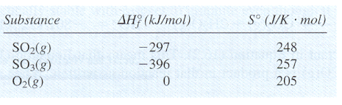
carried out at 25°C and 1 atm. Calculate ∆H°, ∆S°, and ∆G° using the following data:

Hess’s law of summation

Exercise 10 Calculating ∆G°
Using the following data (at 25°C)

C_{diamond}(s)+O₂(g)→CO₂(g) ∆G°= -397 kJ (16.5)
C_{graphite}(s)+O₂(g)→ CO₂(g) ∆G°= -394 kJ (16.6)

Calculate ∆G° for the reaction
C_{diamond}(s)→C_{graphite}(s)

ΔG = ΔG + RT ln (Q)

Exercise 13 Calculating ∆G°

One method for synthesizing methanol (CH₃OH) involves reacting carbon monoxide and hydrogen gases:
CO(g)+2H₂(g)→CH₃OH(l)

Calculate ∆G at 25°C for this reaction where carbon monoxide gas at 5.0 atm and hydrogen gas at 3.0 atm are converted to liquid methanol.

“RatLink”: ΔG° = -RTlnK

Exercise 15 Free Energy and Equilibrium II

The overall reaction for the corrosion (rusting) of iron by oxygen is
4 Fe _{(s)} + 3 O_{2 (g)}  2 Fe₂O₃ _{(s)}
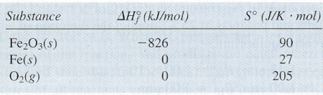
Using the following data, calculate the equilibrium constant for this reaction at 25°C.

Gibb’s equation can also be used to calculate the phase change temperature of a substance. During the phase change, there is an equilibrium between phases so the value of ΔG is zero. Really just like what we did earlier in this unit with enthalpy and entropy!

Sample Problem:
Find the thermodynamic boiling point of H₂O_{(l)} → H₂O_{(g)}
Given the following information:
H_{vap} = +44 kJ S_{vap} = 118.8 J/K

SUMMARY OF FREE ENERGY:
ΔG = + NOT SPONTANEOUS
ΔG = - SPONTANEOUS
Conditions of ΔG:
ΔH ΔS Result
negative positive spontaneous at all temperatures
positive positive spontaneous at high temperatures
negative negative spontaneous at low temperatures
positive negative not spontaneous, ever

Relationship to K and E :
ΔG K E
- at equilibrium; K = 1 0
negative >1, products favored positive
positive <1, reactants favored negative
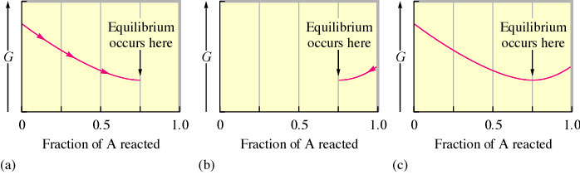
Consider the reaction: A (g)  B (g)
- The change in free energy to reach equilibrium, beginning with 1.0 mol of A(g) at P_{A} = 2.0 atm
- The change in free energy to reach equilibrium, beginning with 1.0 mol of B (g) at P_{B} = 2.0 atm.
- The free energy profile for A (g)  B (g) in a system containing 1.0 mol (A plus B) at P_{TOTAL} = 2.0 atm.

Each point on the curve corresponds to the total free energy of the system for a given combination of A and B.
The value of free energy is not only useful for defining spontaneity. It is also very useful in understanding the maximum amount of work produced or required by a system at constant temperature and pressure:
ΔG = w_{max}
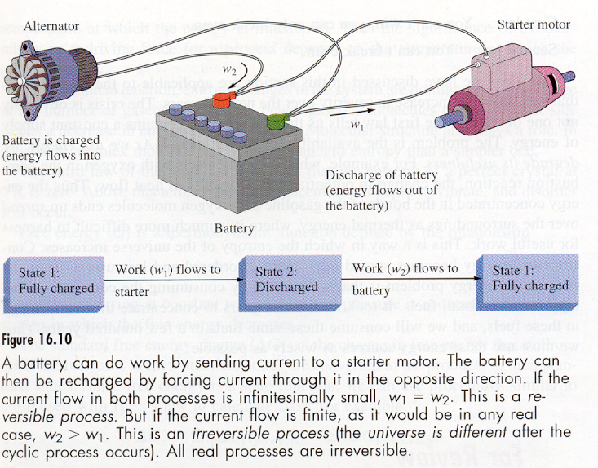
When the reaction is spontaneous, ΔG is the energy available to do work such as moving a piston or flowing of electrons. When ΔG is positive, and thus non-spontaneous, it represents the amount of work needed to make the process occur.

