
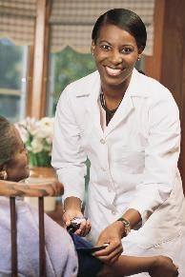

Beaumont Technical Center
3638 Natural Bridge
ST. LOUIS, MISSOURI 63107
Phone: 314.533-2410
Fax: 314.244.1712
Dr. Felita Williams, Principal
E-mail Diane.Hickmon@slps.org

3638 Natural Bridge
St. Louis, Mo 63107
Phone: 314-533-2410
Dr. Felita Williams, Principal

Health Science & Certified Nurse Assistant Pathway
A career in the field of health care is very rewarding with many opportunities for advancement. What better way to begin your career than at Beaumont Technical Center, Health Science/CNA Pathway

Beaumont’s Mission Statement

To provide an exciting and spectacular learning experience with dynamic and inspirational activities facilitated by educators who are passionate and committed to motivate excellence in students and results in competent and compassionate professionals.

Vision

To provide an environment of academic excellence to collaborate with stakeholders & business partners where our students are sought after by colleges, universities and corporates to develop future professionals.

BEAUMONT TECHNICAL CENTER
Your career pathway into the field of nursing & health care
I started in health care over 30 years ago, and it has proven to extremely rewarding. Sharing what I learned with others allows me to help build a community of caring, compassionate and competent health care workers.
Diane Hickmon, MSN-RN

`

CERTIFIED NURSE ASSISTANT (C.N.A.) PATHWAY

Pathway Requirements
Freshmen (9th Grade)
Fr. Literatull agesre and Comp
Algebra or Geometry
Physical Science or Biology
American Government
Physical Exercise

Sophomores (10th Grade)
World Literature
Geometry or Advance Algebra
Biology or AP Biology or Chemistry
World History or AP World U.S. History or AP U.S. History
Health: Career Exploration Survey

Junior (11th Grade
American Literature or AP English Language
Adv. Algebra or Trig/Analytic Geometry or APSat
Chemistry or AP, Chemistry or Physical
U.S. History or AP U.S. History
Prep for National Exams/Law
Health Career Exploration (Health 1)

Senior (12th Grade)
Eng. Literature or AP English Lit or African AM Literature, Trig/Anl Geom or College Algebra or Math Theories or AP Stat or AP Calculus, Physics or Environmental Science or Earth Science or Anatomy & Physiology or AP Chemistry,
Health Career (Direct Patient Care Pathway/
Internship (On-The-Job

***Bold items are highly recommended

Science courses. ***

(These items are NOT SUPPLIED by the school, but purchased by the students in their Junior & Senior year)
Successfully completing the course results in
Students prepared to take the State Certification Examination for Nurse Assistants (written and Practical)
Certified in Cardiopulmonary Resuscitation (Basic Life Support) for Health Care Providers
Resulting in Certified Nurse Assistants ready to enter into the field of Health Care with a solid foundation to build their professional career on.

Student

Requirements
Uniforms (solid color scrubs)
Watch with Second Hand
White Tennis Shoes
Stethoscope
Gait Belt

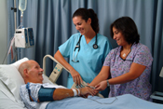
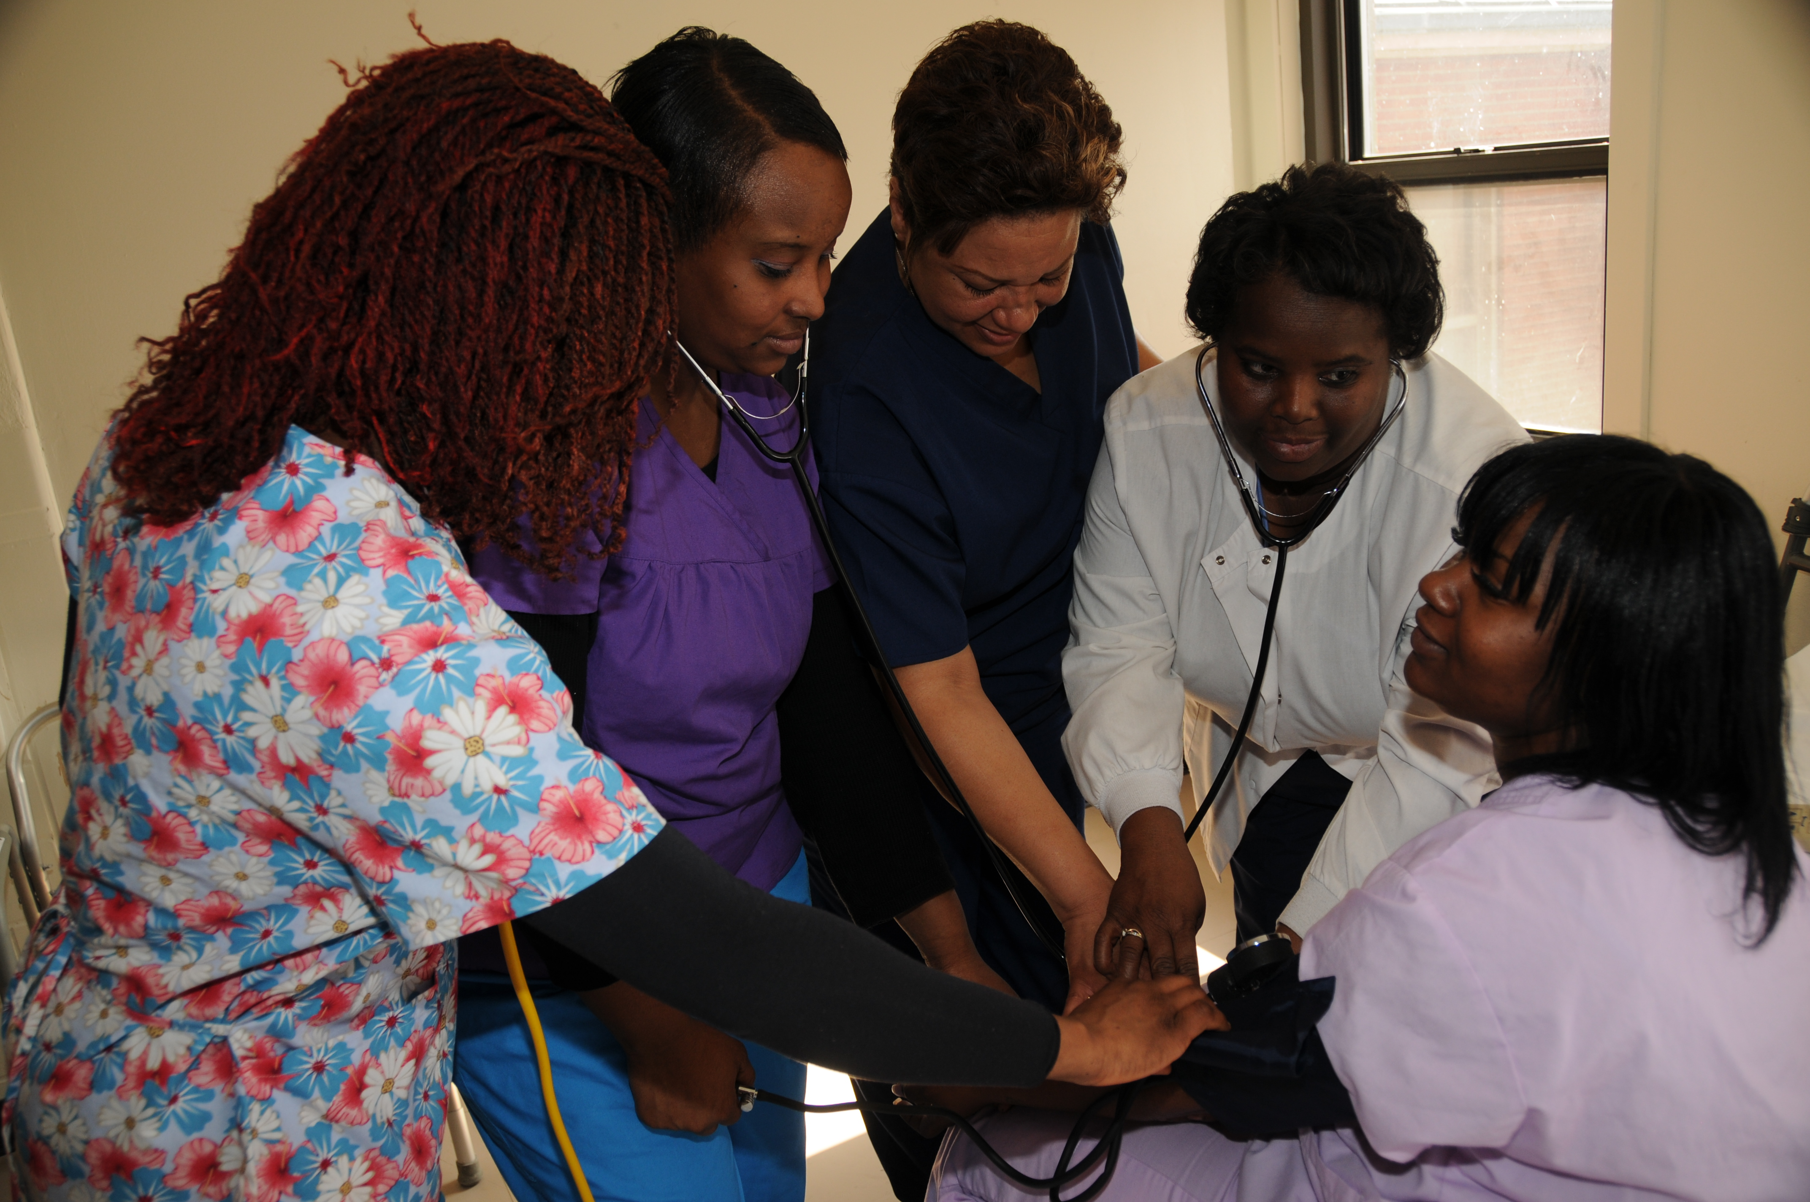

Overview Headline
A Certified Nurse Assistant is an individual who provides direct patient care to Patients, Residents or Clients in need of assistance due to medical and physical reasons
Our Health Science Pathway at Beaumont consist of two parts.
Junior Level which introduce students to entry-level knowledge and skills surrounding Medical Terminology, Human Anatomy & Physiology and basic nursing care for individuals of a
Senior levels students focus on care of the elderly according to MO state guidelines for CNA training, including real-world learning experiences through on-the-job training and job shadowing experience.
Our students develop the following characteristics:
Positive & Caring Attitude
Compassion toward others
Dependability
Team Collaboration
Professionalism
Work well with all individuals regardless of age, socioeconomic, cultural backgrounds or disabilities
(Ill injured or disabled).

