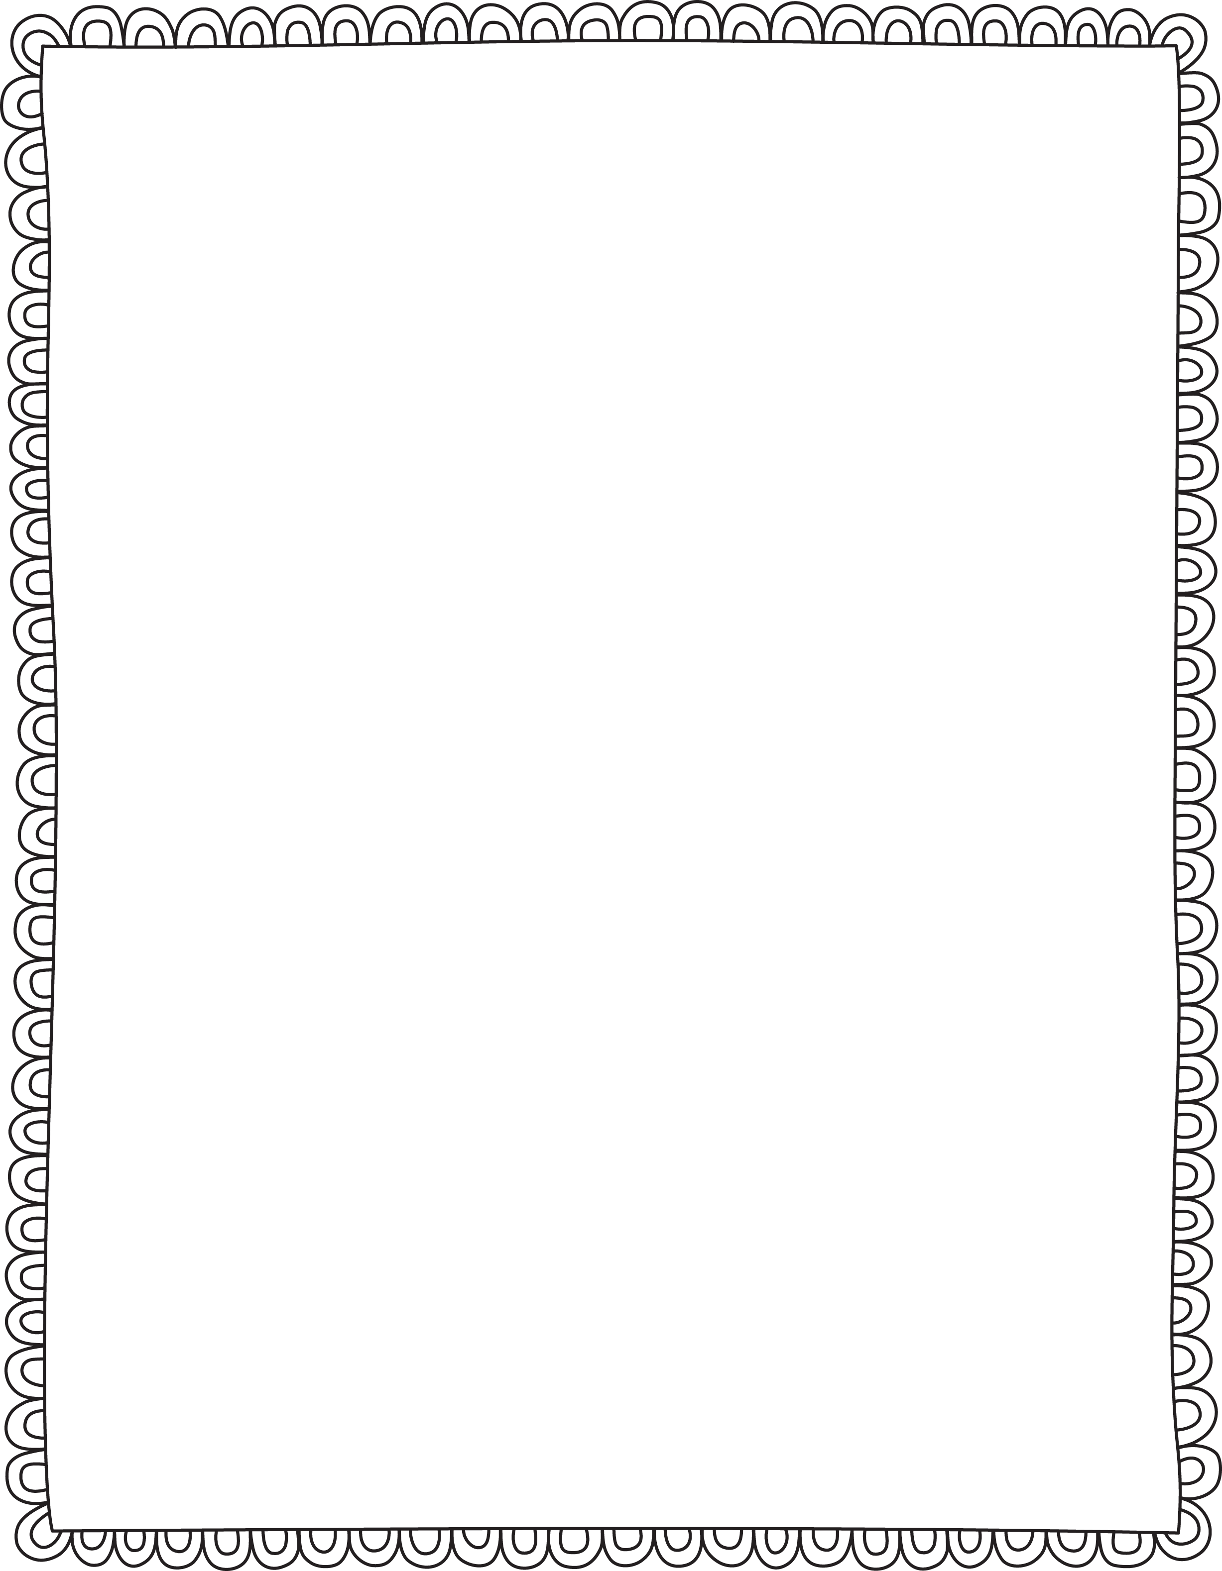

Dear Parents, Guardians, and Grown-Ups,

Welcome to Preschool! My name is Molly Brinkmann and I am so excited to be your child’s teacher. During the year, I will be teaching your children about how to interact with others, making new friends, and following rules and directions. They will be working on being independent while being engaged in hands-on activities.

This is my 8th year teaching at Buder Elementary. I earned my Bachelor’s Degree in Early Childhood Education from Illinois State University. I have my Master’s Degree from Webster University in ECE too. I am certified in Teaching English to Speakers of Other Languages. Outside of teaching, I enjoy walking in Forest Park, seeing my 7 nieces and nephews, and meeting up with friends.

Throughout the year, it is important to have a strong parent-teacher relationship. If at any time you have any questions or concerns please contact me. You can email me at molly.brinkmann@slps.org or send me a message on Dojo.

I am thrilled to be starting on this year’s journey with your children! I look forward to watching them learn, grow and have a fantastic time in preschool!

Best,  
Molly Brinkmann