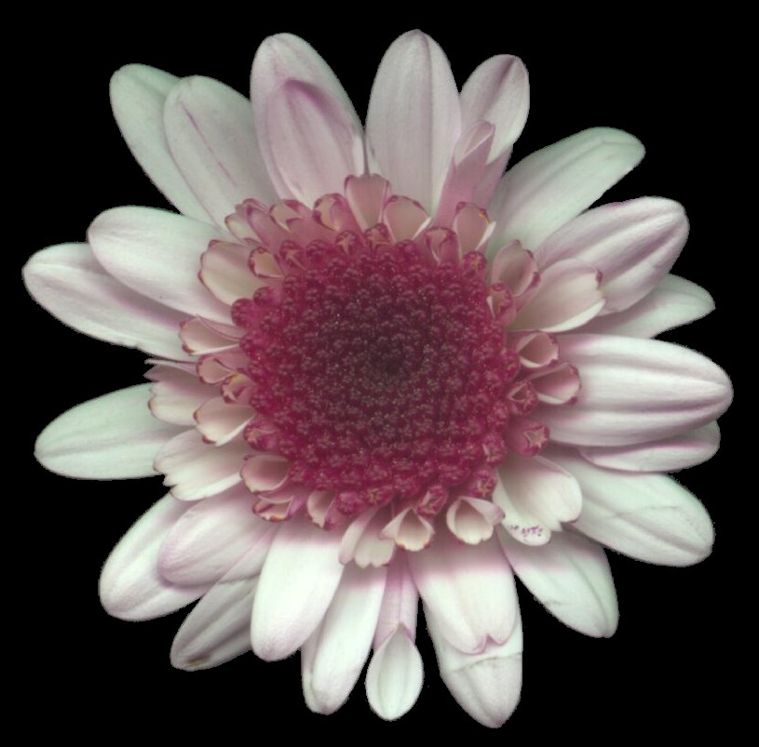

Barnes-Jewish Hospital
St. Louis, Missouri

Mammography Outreach flyer

Barnes-Jewish Hospital, St. Louis, Missouri

Is providing

Free Mammograms
for women age 40 and older with no medical insurance that covers mammograms

When: during the week and every second Saturday of each month

Where: at Barnes-Jewish Hospital’s Breast Health Center and also on the
Barnes-Jewish Hospital’s Mammography Van

TO SCHEDULE AN APPOINTMENT PLEASE CALL: (314) 747-5688

The mammograms will be performed at the Barnes-Jewish Hospital Breast Health Center sponsored in partnership with the Siteman Cancer Center and the Mallinkrodt Institute of Radiology.

These mammograms are funded though grants provided by
Susan G. Komen for the Cure, St. Louis

