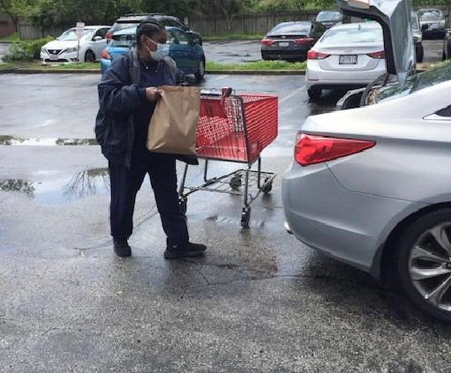

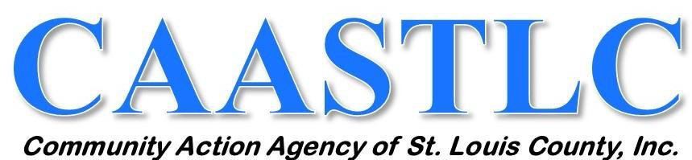

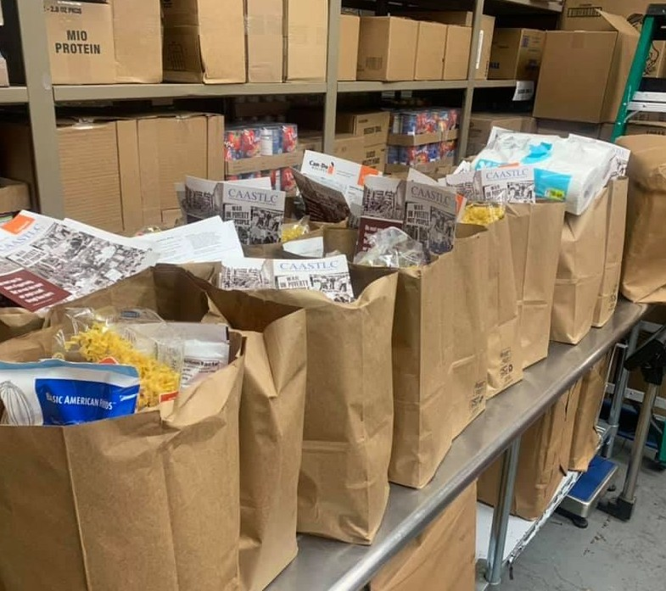

**DRIVE-THROUGH FOOD PANTRY**

## Our quick application process

**and food delivery are safe with no contact. Customers stay in their vehicles. Apply once and**

**receive food monthly.**

**PLEASE CALL (314) 446-4467 TO MAKE AN APPOINTMENT**

# Our food pantry is by APPOINTMENT ONLY and is open to all income-eligible St. Louis County residents.

**This project/program is funded 100% at $150,000 with federal funds received from the U.S. Department of Health and Human Services (HHS) provided by the Missouri Department of Social Services, Family Support Division.**

# C A A S T L C ' S L I H E A P W I N T E R H E A T I N G

**A S S I S T A N C E I N F O R M A T I O N**

### CAASTLC has a number of Energy Services programs designed to alleviate the immediate

**threat of utility service disconnection (i.e., electricity, gas, propane, or heating oil) and assist residents in getting utility service restored to their homes**

**QUALIFICATIONS:**

**-Household income may not exceed 135% of federal poverty guidelines**

**-Households with a member that is at least 60 years old or with special needs (including children) can apply for LIHEAP assistance beginning**

**October 1, 2020**

**-Applications for all others will be accepted beginning November 1, 2020**

**DOCUMENTATION REQUIRED:**

Full Social Security Number(s) on signed application and copy of Social Security Card(s) for people who don't receive food stamps.

Proof of all household income from the previous month if you are not currently receiving Food Stamps or proof of income for any household member(s) not on your Food Stamp case.

Copy of current utility bills/disconnection notices for Spire and Ameren.

**Please visit our website at** [**www.caastlc.org**](http://www.caastlc.org/) **for income eligibility information and applications, or call (314) 446-4420 to get one mailed to you. Please mail completed application to the main office address listed below or fax it to (314) 446-4480. Applications can also be submitted online at https://mydss.mo.gov/energy-assistance.**

This project/program is funded 100% at $6,925,751 with federal funds received from the U.S. Department of Health and Human Services (HHS) provided by the Missouri Department of Social Services, Family Support Division.

**(314) 863-0015**

[**www.caastlc.org**](http://www.caastlc.org/)

**MAIN OFFICE**



**2709 Woodson Road**

**Overland, MO 63114**

**NORTH OFFICE**

**26B North Oaks Plaza Northwoods, MO 63121**